|  |  |  |
| --- | --- | --- |
| **LAB 321Assignment** | **Type:** | **LongAssignment** |
| **Code:** | **J3.L.P0050** |
| **LOC:** | **750** |
| **Slot(s):** | **15** |

**Title:** Market place

**Background**

This is a small shop online. Buyer can view products and order them.

**Program Specifications**

Program a web site display all recipes. Each of recipes can be viewed detail. And, visitor can write comment.

**Features:**

This website contains following main functions

* Function 1: Home page – Display all products – Screen code **S001**
  + Maximum of articles on home page is 9
  + Use paging to load more products
  + All image of product on homepage are set general size
* Function 2: Product detail – Screen code **S002**
* Function 3: Your basket – Screen code **S003**
  + Display all order of customer
* Function 4: Checkout – Screen code **S004**
* Fill customer ‘s information
* Function 5: Confirm order – Screen code **S005**

Database description (recomment)

* Product
* Customer
* Order

***Expectation of User interface:***

**S001**

➀ Menu home page. Action: Click 🡪 Open S001

➁ Open Basket page (S003)

➂ Open the product detail page (S002)

➃ Add product to basket function

➄ Open checkout page (S004)

6 – Banner of ads

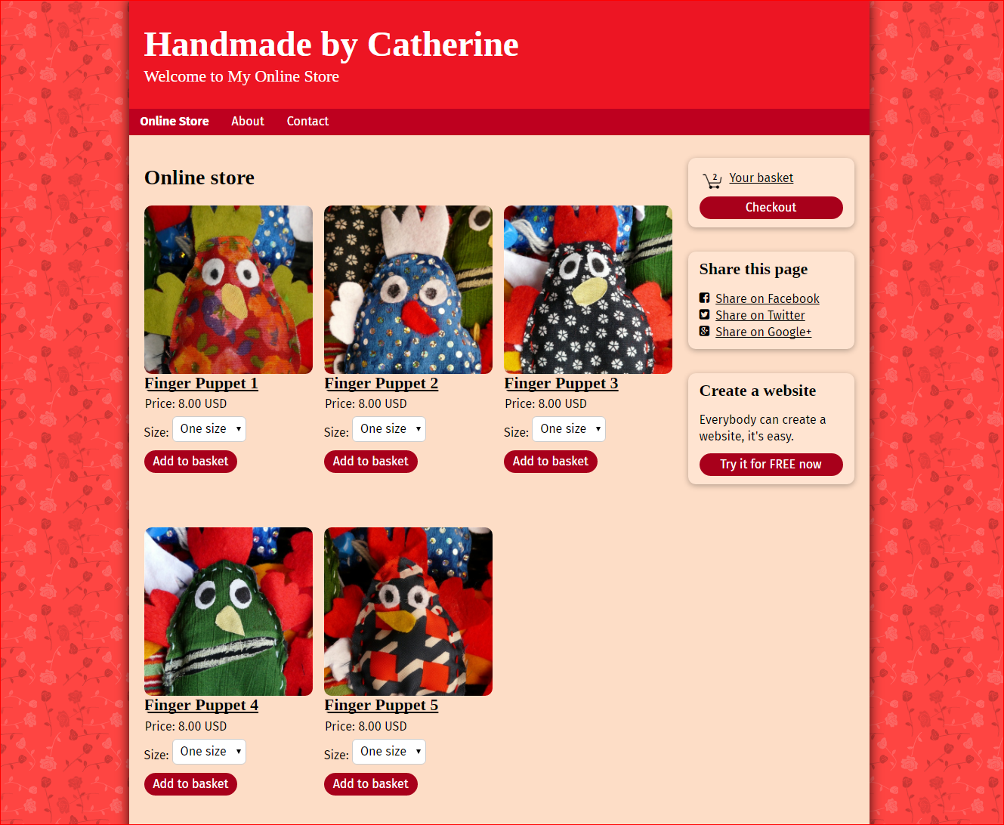

**S002**

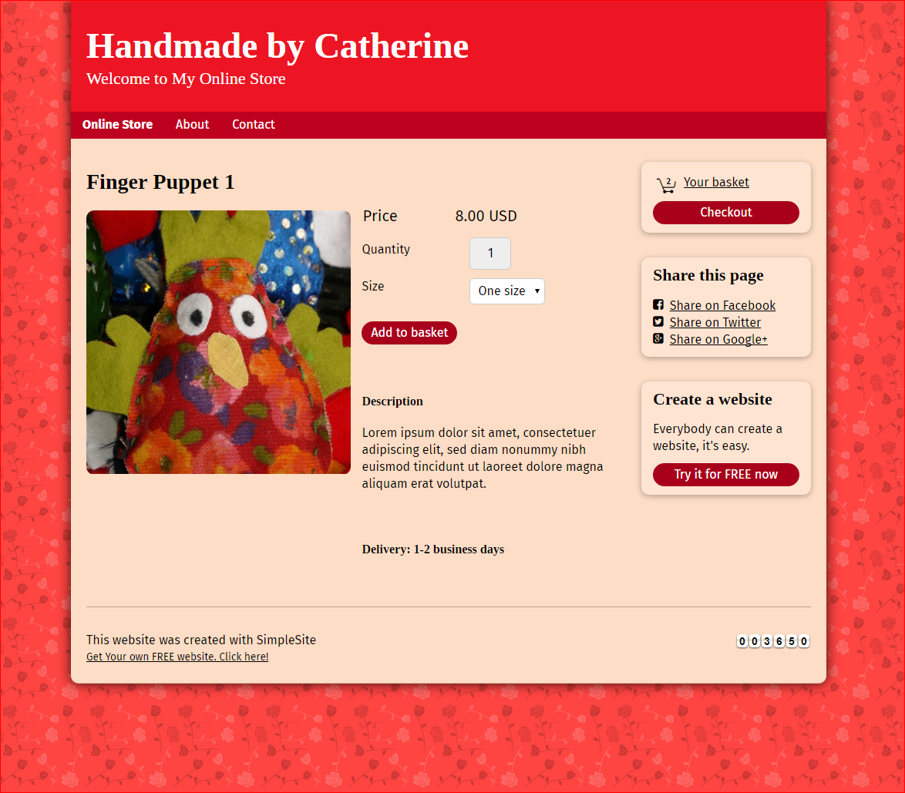

**S003**

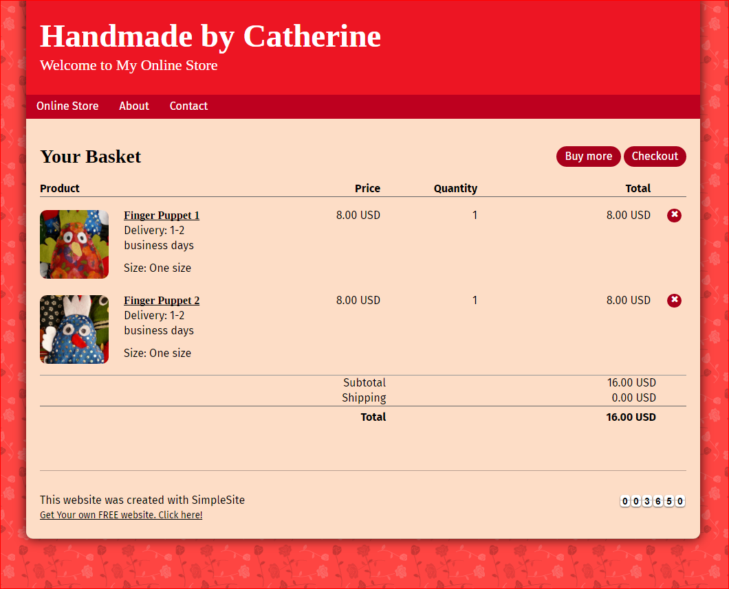

**S004**

Save customer’s information at client cache for next checkout. (Customer don’t need to fill data again)

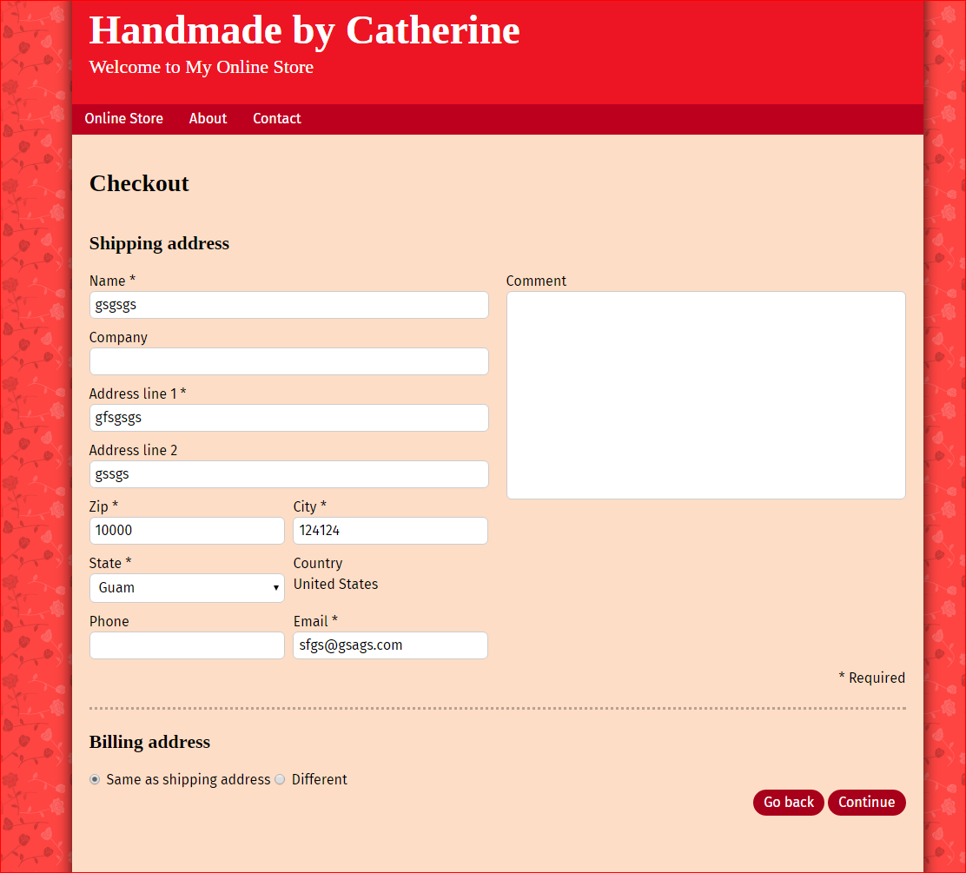

**S005**

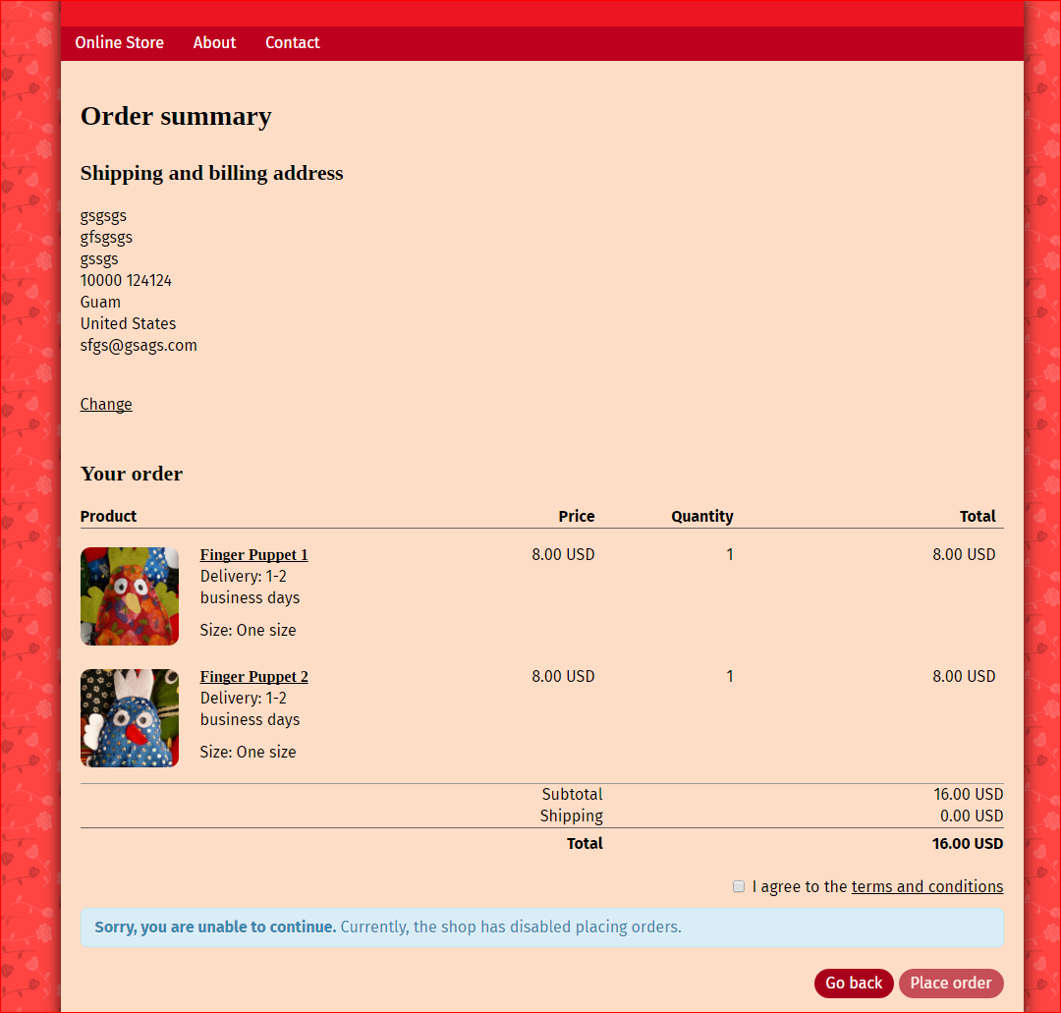

**Guidelines**

* Step 1 : Create web layout
* Step 2 : Create prototype
* Step 3 : Design database base on created prototype
* Step 4 : Code & Test